LLCIS+ – Language Learning and Cultural Integration Support Project for Migrants and Refugees
WORKSHEET
Design an Inclusive Digital Learning Activity
Training on the use of digital tools in education and their application to new learning methodologies
Portugal | 15 September 2026 | Work in small groups (3–5 people)
  Digital  Tools | 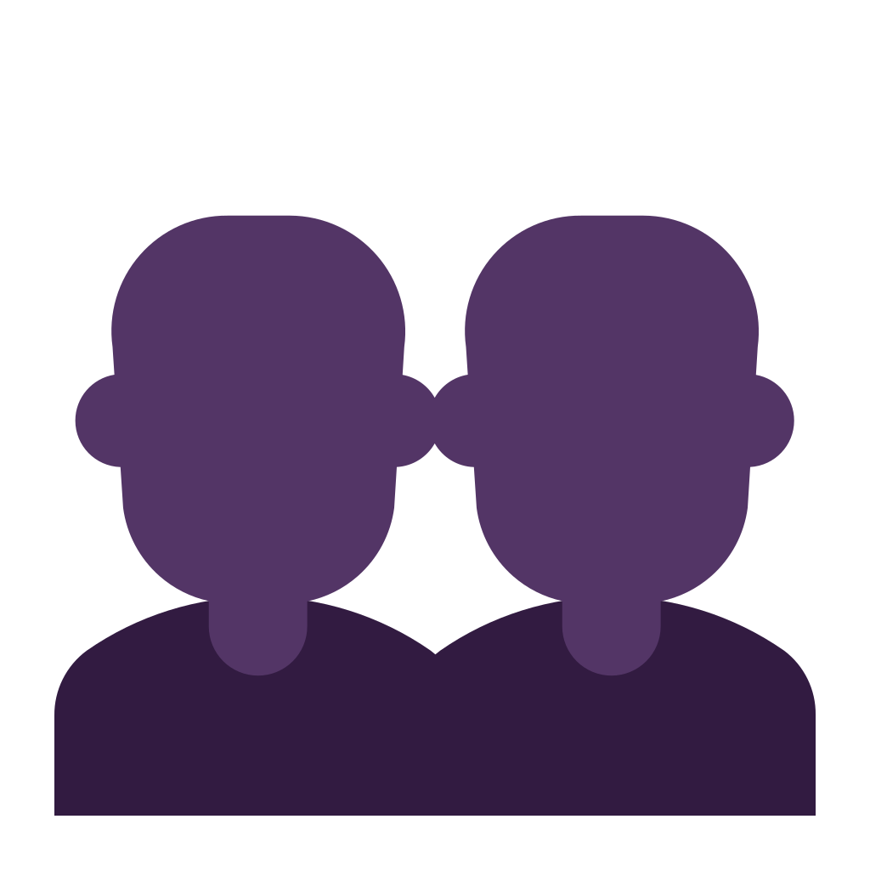  Collaborative  Work |   Integration  Needs |   Inclusive  Learning

Instructions
• Choose a learning objective and a target group.
• Choose a real-life integration need.
• Select a methodology and a digital tool.
• Design the activity and prepare a short 3-minute presentation.

Group number | Example Group 1
Participants | Amina, Samir, Fatima, Youssef

Activity title | How to Book a Medical Appointment
Learning objective | Learners identify the steps needed to book a medical appointment and practise simple healthcare vocabulary and communication.
Target group | Newly arrived adult migrants and refugees with basic digital skills and beginner/intermediate English or Portuguese support.
Real-life integration need | Access to healthcare.
Methodology | Problem-Based Learning + Collaborative Learning
Digital tool(s) | Padlet
Duration | 45 minutes
Materials needed | Smartphone or laptop, internet connection, projector, Padlet board, and a short scenario card.
Step-by-step procedure | 1. The trainer presents the scenario: “You need to book a medical appointment, but you do not know the steps.”  2. In small groups, participants discuss what they already know and list the steps they think are necessary.  3. Each group posts its ideas on Padlet.  4. The class compares the posts, discusses the correct order, and adds missing information with support from the trainer.  5. Each group prepares a short 3-minute presentation explaining the process and the reasons for its choices.
Inclusive adaptation | Use simple language, visual prompts/icons, peer support in small groups, optional bilingual help, and extra time for reading and discussion.
Assessment method | Observation of participation, review of the Padlet contribution, and a quick oral self-assessment at the end.
Expected final product | A completed Padlet with the key steps for booking a medical appointment and a short group presentation.
3-minute presentation notes | Explain the target group, learning objective, integration need, methodology, digital tool, main activity steps, inclusive adaptations, and the expected result.

Tip: Start from a real-life need, choose the methodology first, and only then choose the digital tool.
Training resource developed for the LLCIS+ project.

