 | 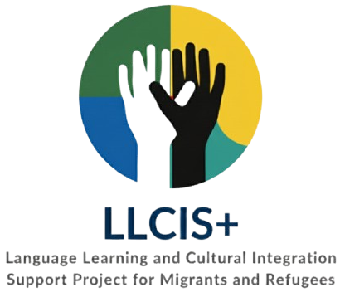 | 
━━━━━━━━━━━━━━━━━━━━━━━━━━━━━━━━━━━━━━━━━━━━━━━━━━━━━━━━━━━━━━━━━━━━━━━━
AI-Supported Learning Activity Canvas
Quick Planning Canvas – AI for Personalised Learning
Use this page to quickly plan an inclusive, personalised learning activity for migrants or refugees.
1. WHO?  Who are the learners? Think about age, language level, digital skills and context.  Example: Adult migrant, A2 Portuguese, basic digital skills, looking for work.  ________________________________________________  ________________________________________________ | 2. NEED  What do they need to learn, practise or improve?  Example: Practise simple job interview questions and improve employment vocabulary.  ________________________________________________  ________________________________________________
3. AI SUPPORT  How can AI support the learning process?  Example: AI generates A2-level interview questions and gives simple feedback.  ________________________________________________  ________________________________________________ | 4. LEARNING ACTIVITY  What will learners actually do? Keep it practical and achievable.  Example: Answer 5 interview questions orally or in writing, then improve the answers.  ________________________________________________  ________________________________________________
5. ADAPTATION  How will you personalise the activity or make it more accessible?  Example: Simplified language, audio support, translation and oral or written response options.  ________________________________________________  ________________________________________________ | 6. OUTCOME  What should learners be able to do at the end?  Example: Answer 3–5 common interview questions with more confidence.  ________________________________________________  ________________________________________________
Tip: The examples are only a starting point — use them to imagine a different learner, need or activity.
Quick details
Tools used: __________________________________ | Estimated time: __________________________________
Learner → Need → AI → Activity → Adaptation → Outcome

